|  |  |
| --- | --- |
| Kopiereg voorbehou | Copyright reserved |
| Universiteit van Pretoria / University of PretoriaDepartement Chemiese Ingenieurswese / Department of Chemical Engineering | |
| CIR 310  NAVORSINGSOPDRAG  Totale Punte: 50  Tydsduur: 5 Weke | CIR 310  RESEARCH ASSIGNMENT  Total Marks: 50  Time: 5 weeks |

CIR310 ASSIGNMENT 2016

The assignment must be submitted in the form of a group summary report of not less than eight pages and not more than twenty pages including the title page and illustrations. This submission must conform to the “Guidelines for Writing Technical Reports and Papers” issued by the Department of Chemical Engineering. Copies of this document can be obtained from the Departmental website. You should consult a minimum of five sources (scientific books and journal articles). These references must be cited using the “Harvard” method. Please use single line spacing and Times New Roman font (12 pt). In addition to the written report, your group will present your findings via a Powerpoint presentation with a maximum of 12 slides. Lastly, your document, your group’s PowerPoint presentation and where possible, a YouTube video must be supplied on a CD or uploaded to a dedicated Dropbox folder to be advised.

**Research topic: Assessing the utility of the unified algorithm proposed by Jaubert & Privat to solve fluid phase equilibria using the 'γ-ϕ' and the 'ϕ-ϕ' approaches for binary mixtures**

**Submission date: 13h30 Monday 23 May**

Please read the PowerPoint presentation of Jaubert & Privat. Each group will get their own unique data set. You will be required to fit the isothermal VLE data using two different approaches:

1. The γ-ϕ method using the Wilson activity coefficient model
2. The ϕ-ϕ method using the Peng-Robinson EoS with classical mixing rules

In Method 1 you will need to make corrections for the non-ideal behaviour of the vapour phase through the use of the truncated virial equation of state.

In Method 2 you will need to determine the EOS parameters from critical data and vapour pressures data.

You must implement the algorithm proposed by Jaubert & Privat either in a Python programme or in an Excel spread sheet. Use these to solve your system. The main outputs required are the oprimized P-x-y (or T-x-y) and y1-x1 phase diagrams predicted by the two approaches. Make sure that the experimental data is shown by discrete symbols while the predictions are indicated by solid lines on your graphs. See the example shown in the Figure.

NB! Please use SI units!

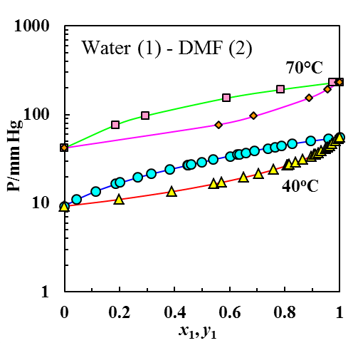

Figure: Water (1) – DMF (2) VLE phase diagram